San Diego County TJC Initiative Structure
Data and Evaluation
Transition and Community Supervision
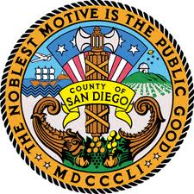
Program and Curricula
Workgroup 4
Outcome Measures/Evaluation
Workgroup 3
Intervention and Evidence Based Practices Supervision Services
Workgroup 2
Alternative Sentencing
(part of workgroup 1 & 3)
Community Corrections Partnership (CCP) Executive Committee
Chair – Chief Probation Officer Mack Jenkins
CCP Steering Committee
Chair – San Diego Superior Court Special Projects Manager Scott Brown
Workgroup 1
Pre-Trial Custody, Process, and Disposition
CCP Subcommittees
Screening and Assessment
Transition from Jail to Community
Core Team
Chair – San Diego Sheriff's Department Captain Billy Duke

